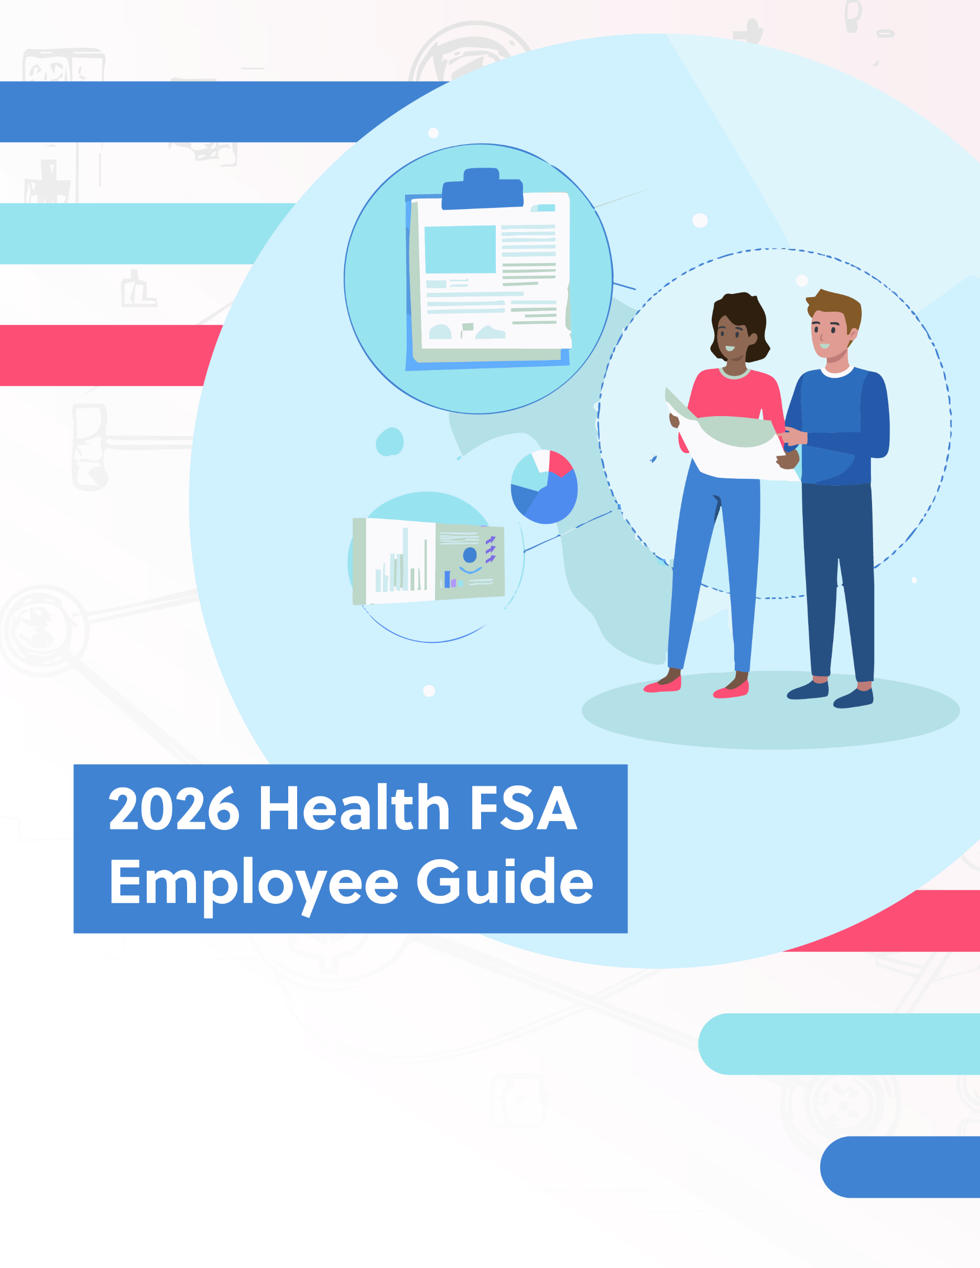

Table of Contents

What are Health FSA's? 3
Why Have a Health FSA? 4
Health FSA Advantages 4
Is a Health FSA Right for You? 4
How do FSA’s Work 5
FSA Eligibility 5
Opening Your FSA 5
Contributions 5
Grace Periods and Carry-overs 5
Using Your Health FSA 6
Health Payment Card 6
Reimbursement 7
Qualified Expenses 7
Life Events 7
FSA Recordkeeping 7
Appendix—Qualified Medical Expenses 8


Paying for health expenses can be stressful, but planning ahead and putting money in a health flexible spending account (FSA) will help you save on taxes while keeping a reserve of money available for health care costs. Although FSAs are a great way to help you pay for medical expenses, they can be confusing if you haven’t worked with one before. This guide will walk you through what health FSAs are, what they can pay for and how they work.

What Are Health FSAs?
An FSA is an employer-sponsored savings account for health care expenses. You are not taxed on the money put into the FSA, and you can then use the account to pay for qualified out-of-pocket health care costs, such as your deductible and copays, but not your premium. However, you cannot stockpile money in the account from year to year, and you will lose leftover money in the account at the end of the plan year unless your employer offers an option that allows for either a short extension or a small carry-over into the next year.
FSAs were created in the 1970s to enable employees to use pre-tax dollars for health care expenses that were not otherwise covered by employer-sponsored health coverage. These accounts gained more popularity in the 2000s, and they underwent a few changes with the Affordable Care Act (ACA), including the addition of an annual contribution limit.
Health FSAs can save you money on taxes while helping you regularly put aside money for health care expenses. If carefully planned, using an FSA for health care costs can be an asset to your family’s budget.

Why Have a Health FSA?
Health FSAs offer an option for setting aside money to use forqualified medical expenses. These accounts offer a convenient way to prepare for out-of-pocket medical expenses while saving on taxes. In addition, you can use your health FSA to pay not only for your medical expenses, but also for the medical expenses of your spouse and dependents.

Health FSA Advantages
Here are some of the advantages an FSA can provide:
Tax reductions: The amount you contribute to a health FSA is not subject to federal income tax or social security (FICA) tax—effectively adjusting your annual taxable salary. The taxes you pay each paycheck and collectively each plan year can be reduced significantly.
- Your employer can also contribute to your FSA, and this amount is also not considered taxable income to you.
- You can withdraw money from your FSA to pay for qualified medical expenses (see Appendix) and your withdrawals are not taxed.
- You do not have to report FSA amounts on your income tax return.
Convenience: After the initial election at the beginning of the year, your employer will take care of transferring the allotted amount into your FSA through salary deferral.
Flexibility: You can withdraw health FSA funds at any time (for qualified medical expenses), even if the amount has not yet been deposited into the account, as long as the amount is no more than your elected annual deferral amountless any amount already used.

Is a Health FSA Right for You?
FSAs can save you money because you don’t have to pay taxes on the amount deferred to the account.However, using an FSA does require careful planning in order to reap the financial benefits.
When you participate in an FSA, you have to decide at the beginning of the plan year how much to contribute for the year. Because you will generally lose what you don’t use by the end of the year, determining how much to defer into an FSA can be challenging. While correctly estimating your health care expenses and using an FSA to pay for those expenses will save you money, incorrectly gauging your health costs could cause you to lose money.
How your employer manages the FSA may also affect how much you will benefit from using an FSA. If the employer provides a grace period or carry-over option (see “Grace periods and carry-overs” section), you will have a little more flexibility when using your FSA funds. The largest downside to using an FSA is that if you overfund your FSA and don’t use the amount in there, you will lose what you’ve saved.

How Do Health FSAs Work?
At the beginning of the year, you elect the total amount you want to have withdrawn from your paychecksto put into your FSA, and your employer will deposit the money into the account in equal allotments throughout the year. The IRS has outlined rules guiding eligibility, contributions and reimbursements.

FSA Eligibility
FSAs are employer-sponsored benefit plans, and the employer can choose what other type of group health plan coverage to offer with the FSA. FSAs can be offered with any type of health plan—FSAs are not tied to a high deductible health plan (HDHP) like health savings accounts (HSAs) are. Self-employed individuals are not eligible for an FSA, and restrictions may apply for highly compensated individuals or key employees.

Opening Your FSA
The FSA is sponsored by your employer as one of your employee benefits. You will need to choose how much you want to contribute to your FSA. The amount you elect will be for the entire plan year, and your employer will then deduct the corresponding amount from your paycheck with each pay cycle. This is sometimes referred to as a salary reduction arrangement.

Contributions
After your initial contribution election, you ordinarily cannot change your election for a plan year during the year. Your elected contribution amount can only be changed if you experience a permitted election changeevent, such as a change in family status and your FSA permits you to change your election.
The amount you choose to transfer into your FSA should be based on the amount of qualifying medical expenses you anticipate your family incurring during the plan year. Start by looking at your family’s medical expenses for the past year and then determine whether your family will likely have those same expenses again and whether there will likelybe any new expenses. Use this estimate to help you choose what amount you would like to contribute to your FSA, remembering that it is typically best to underestimate by a little than to overestimate and lose that money at the end of the year.
Limits– In 2026, the maximum amount you can contribute to your FSA is $3,400, which is indexed for inflation and therefore may change year to year. The employer may implement a lower annual limit than the federal maximum.
Who can contribute – Both you and your employer may contribute to your FSA. However, your employer is not obligated to contribute to the account.

Grace Periods and Carry-overs
The FSA operates with a use-or-lose rule, meaning if you don’t use the money in your FSA by the end of the plan year, you will lose it. However, the use-or-lose rule was relaxed with two options that employers may choose to offer: a grace period or a carry-over. The grace period can last up to 2 ½ monthsinto the next year, typically March 15 for a calendar year plan. Generally, only expenses you incur during the plan year can be reimbursed from the funds in your FSA, but if your FSA has a grace period, you can use those unused funds in your FSA for expenses incurred during the grace period.
Under the carry-over option, an FSA may allow employers the option of allowing employees to carry over up to $680 of unused funds from one year to the next beginning in 2026. The carry-over does not count toward the annual maximum allowable contribution.Employers are not required to offer either of these options, and they may only offer one of the two options, not both.
If you have funds in your FSA at the end of the year, you might consider scheduling a checkup, dental cleaning or similar appointment before the end of the year in order to use up the leftover funds before they are lost.

Using Your Health FSA
FSAs must comply with a uniform coverage rule. The uniform coverage rule provides that an employee’s entire annual FSA election amount, less any amount already used, must be available at any time of the plan year—even if that full amount has yet to be contributed to the account. This means that the entire amount of your election is available for your use at any time of the year. For example, if you elect $1,000 for your annual contribution, and you incur qualified medical expenses of $800 in January, your FSA will reimburse you for the $800 even though that amount has not yet been deducted from your salary.
When you are paying for a qualified medical expense that you would like to use your FSA funds for, you typically have two choices: using a health payment card or requesting reimbursement.

Health Payment Card
Some employers may provide you with a health care payment card, which is very similar to a debit or credit card, and you can pay for eligible medical services or products by swiping the card as you would a debit or credit card. The money will then be deducted from your FSA account.
Health care payment cards may be used only on eligible medical expenses that are not reimbursed or covered by another source. Over-the-counter (OTC) medications are only eligible for reimbursement if they are prescribed to you, and you present the prescription at the time of purchase. The only OTC medication that can be reimbursed without a prescription is insulin. Health care payment cards may not be used to cover more than the maximum dollar amount of coverage available in your FSA.
As a general rule, every claim paid with a health care payment card must be reviewed and substantiated. The IRS guidance allows automatic adjudication for certain card transactions, meaning that receipts do not need to be submitted for verification of expenses for which a health care payment card is used. This applies in three situations at medical providers and 90-percent pharmacies (drug stores and pharmacies where at least 90% of the store’s gross receipts during the prior taxable year consisted of medical expenses):
- When the total cost of the transaction is equal to the standard copayment for the service(s) received
- When the transaction is for recurring expenses that have previously been approved
- When the merchant provides expense verification to the employer when the transaction takes place

Reimbursement
Another way to pay for eligible medical expenses with your FSA funds is to pay out-of-pocket and then submit receipts for reimbursement. Your account will have specific instructions for how to do this. When submitting for reimbursement, you will need your receipts and proof that what you paid for was an eligible medical expense; this is one of the reasons it is important to keep all receipts and related paperwork from your health care provider.

Qualified Expenses
Employees may use their health FSAs to pay for or reimburse themselves for their own eligible medical expenses, as well as their spouses’ and dependents’ eligible medical expenses. Eligible medical expenses are unreimbursed medical care expenses, as defined under Section 213(d) of the Internal Revenue Code. An employer can more narrowly define the expenses that can be reimbursed from an FSA. Health FSAs cannot be used to pay for non-medical expenses. Your FSA cannot be used to pay for health insurance premiums, long-term care coverage or expenses, or amounts already covered under another health plan. See Appendix for a list of qualified medical expenses.

Life Events
Certain life events may affect your FSA.
Employment status changes – Your employer owns the FSA. Typically, if you leave your job before you’ve used the FSA funds, the employer will keep the amount left in the account. However, you may be eligible to elect COBRA and continue your FSA until the end of the year.
Death – If you die, the contributions to your FSA willstop, but your survivors can file claims until the filing deadline for any remaining eligible expenses that you or your family members incurred.

FSA Recordkeeping
In most cases, you will have to submit receipts and otherproof that you purchased an eligible medical service or product in order to receive reimbursement. Make sure you retain all receipts, Explanation of Benefits (EOBs) and other documents to ensure that you have the necessary proof to obtain reimbursement from your FSA.

Appendix—Qualified Medical Expenses
The qualified medical expenses that can be reimbursed by an FSA on a tax-free basis are limited to expenses for medical care (as defined in the federal tax code) for the employee and his or her spouse and dependents, to the extent those expenses are not reimbursed by any other health coverage. The federal tax code defines medical care expenses as amounts paid for the diagnosis, cure, mitigation or treatment of a disease, and for treatments affecting any part or function of the body. The expenses must be primarily to alleviate a physical or mental defect or illness.
The products and services listed below are examples of medical expenses that may be eligible for payment under your Flexible Spending Account, when such services are not covered by your health plan. This list is not exhaustive; additional expenses may qualify as medical expenses, and the items listed below are subject to change. Also, your FSA plan may have additional restrictions on the types of expenses it will reimburse.
- Acupuncture
- Alcoholism treatment
- Ambulance
- Annual physical exam
- Artificial limb
- Artificial teeth
- Bandages
- Birth control pills
- Body scan
- Breast pumps and supplies
- Breast reconstruction surgery following mastectomy for cancer
- Capital expenses (improvements or special equipment installed to a home, if meant to accommodate a disabled condition)
- Car modifications or special equipment installed for a person with a disability
- Chiropractor
- Contact lenses
- Crutches
- Dental treatment (not including teeth whitening)
- Diagnostic devices
- Disabled dependent care expenses (medical care of the disabled dependent)
- Drug addiction treatment
- Eye exam
- Eye glasses
- Eye surgery
- Fertility enhancement (for example, in vitro fertilization or surgery)
- Guide dog or other service animal
- Hospital services
- Laboratory fees
- Lactation expenses
- Lodging at a hospital or similar institution
- Medical conference expenses, if the conference concerns a chronic illness of yourself, your spouse or your dependent
- Medical information plan
- Medications, if prescribed
- Nursing services
- Operations
- Optometrist
- Osteopath
- Oxygen
- Personal protective equipment used for the primary purpose of preventing the spread of COVID-19
- Physical exam
- Pregnancy test kit
- Prosthesis
- Psychiatric care
- Psychoanalysis
- Psychologist
- Sterilization
- Stop-smoking programs
- Surgery
- Special telephone for hearing-impaired individual
- Television for hearing-impaired individuals
- Therapy received as medical treatment
- Transplants
- Transportation for medical care
- Vasectomy
- Vision correction surgery
- Weight-loss program if it is a treatment for a specific disease
- Wheelchair
- X-rays

